CILIP Conference Report – 5th & 6th July 2017
Donna Murtha
Librarian
I was extremely grateful to be awarded a bursary from YOHHLNET to attend the CILIP conference in Manchester. Although I’ve worked in libraries for 14 years, this would be my first CILIP conference. It coincided with my move into professional registration and my new job as a librarian. I currently work in a small team, and although I love working in a small team, I wanted an opportunity to see what the rest of the library world was working on, and if we could implement any of the into our small NHS library. I hoped the conference would inspire me, and it did not disappoint!
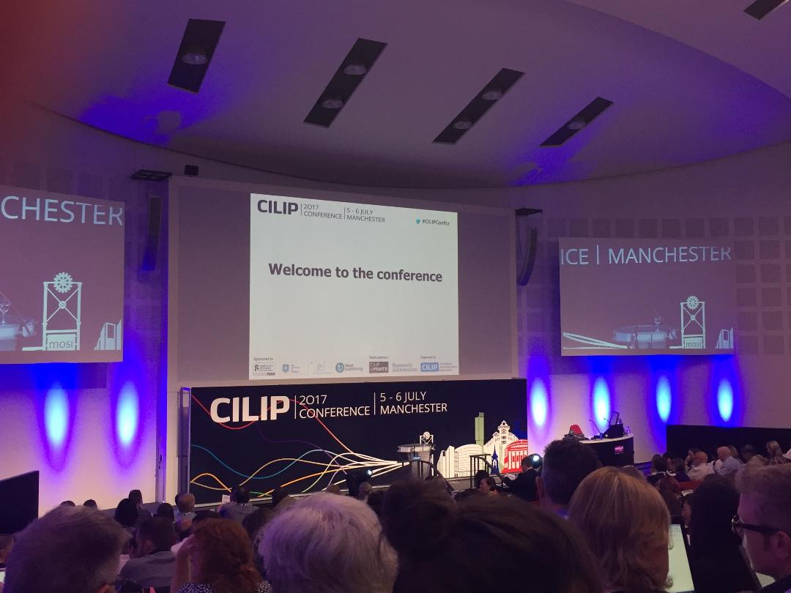
Keynotes speakers:
I found the keynote speakers to be completely engaging.
I’ve been a big fan of Dr. Carla Hayden for a while and was looking forward to hearing her speak. Apart from fan-girling a few times when she walked past, I managed to restrain myself from getting her autograph! Her keynote speech was based around making library collections more accessible and inclusive to various community groups. She’s had a very interesting career and is an inspiration to someone like me who is just starting out on the professional ladder.
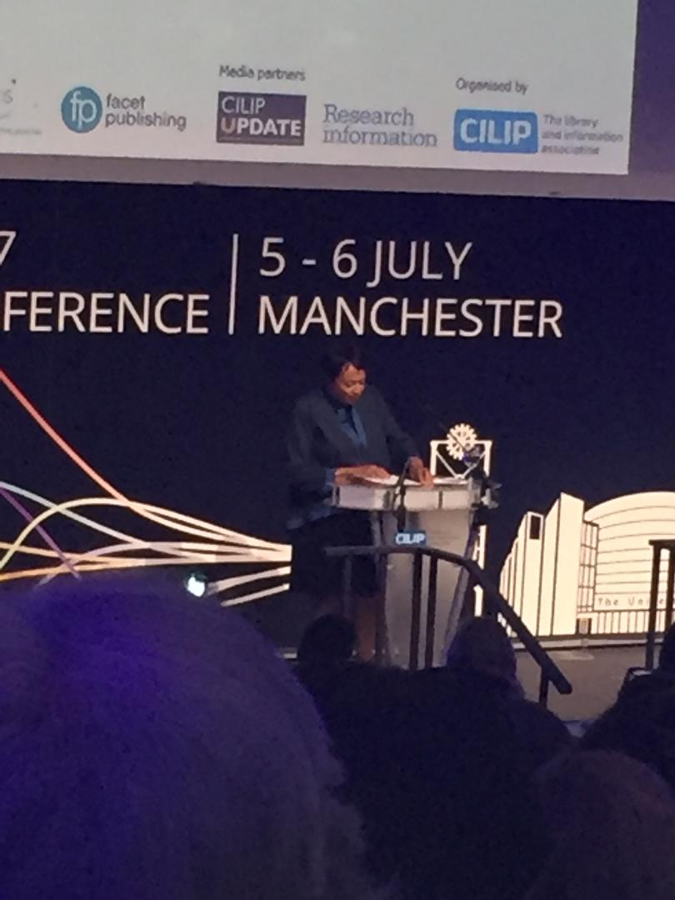
Dr. Carla Hayden – keynote speaker from Library of Congress
Surprisingly, the keynote which made me think the most was given by Luciano Floridi on fostering the information sphere. Although theoretically heavy, the main gist of the presentation was whoever controls access to information in society controls the power balance.
“Who controls the questions shapes the answers.
Who shapes the answer controls reality.”
He suggested libraries roles are to counterbalance this power by guaranteeing and facilitating free and effective formulation of questions.
Workshops:
I attended a number of workshops including Rethinking Libraries, Sustaining our Common Goals, Global Commitments: Libraries and UN Sustainability Goals, Human Rights, Beyond Grey in Sepia: Empowering the Everyday Life of Syrian Refuges, and the Epidemic of Misinformation around Vaccines.
The conference gave me an opportunity to attend workshops outside my library sector. It broadened my knowledge of what is happening in the professional nationally and globally in a variety of sectors.
The two workshops I found most interesting were the sessions on human rights, especially with the political climate in certain parts of the world and how libraries can become cornerstones of democracy, and the misinformation around vaccines.
Tips and tricks for the conference with a disability:
As a lupus sufferer, I find my energy levels dip dramatically during the afternoon. Add in the daily back and forth travel to Manchester and I wasn’t sure how I would cope with a fully packed two days. This is one of the reasons I’ve avoiding going to professional conferences in the past.
I learnt a number of coping strategies and thought I would share with everyone who attends a conference regardless of physical ability:
- Sit down as much as possible when seating is available – for lunch and networking opportunities there was very little seating, so sit down while you have a chance!
- Wear flat shoes – there is LOTS of walking around so you need to be as comfortable as possible.
- Take some time out – there are so many sessions and so many interesting new people, it can be overwhelming. Take 10 minutes by yourself to process all the information.
- Make use of the quiet, reflection room – I only found out about this on the second day, but CILIP provided a quiet place to just sit and be for a while.
What impacted on me the most?
Luciano Floridi’s keynote speech on libraries as democratic institutions providing a counterbalance to socio-political control. A call to action and very thought-provoking stuff.
What was the most valuable thing I took back to my workplace?
The ethics workshop, Sustaining our Common Goals. The speakers in this workshop suggested the library profession as a whole needs to embrace debate. That we need to admit our responsibility in weakening our values. We need to engage more with each other and become more reflective, and open to criticism and debate.
This session made me think about more engagement with my profession outside of the health sector, and the potential for research into the profession – which is something we don’t necessarily think of doing on a daily basis yet we encourage it in our NHS users.
And finally…
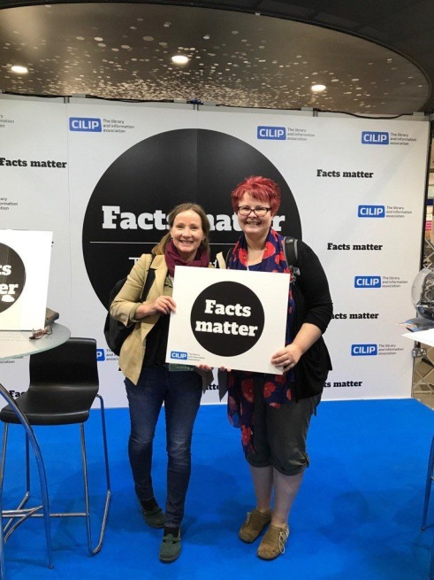
Helen Rutherford on the left and myself on the left
The CILIP conference involved two hectic, jam packed days of inspiring workshops and keynote speakers. It was one of the most inspiring and friendly conferences I’ve attended. My advice to anyone thinking about attending in the future is go for it! No matter what stage of your professional career, or what areas you work in, the CILIP conference provides something for everyone and gives a broader outlook on the library profession.

