

Searching For Healthcare Information

Accessing OVID databases
Go to the library webpage www.mft.nhs.uk/library > Online resources > Healthcare Databases.
You will then see the Ovid databases available to you. Login using your OpenAthens username and password. You will also need to create an account with OVID if you wish to save your searches.

After logging in with OpenAthens you will be taken to the resources list. In order to make full use of advanced searching features, we strongly recommend you search one database at a time.
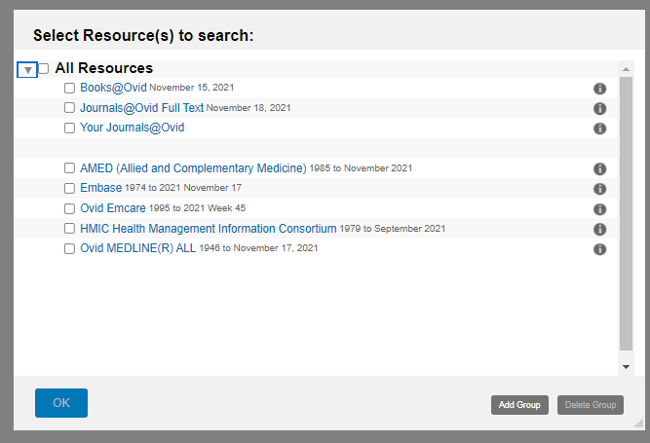

How to Search
Firstly you need to formulate a clear question. This should generate search terms. There are models which may help you do this such as PICO:

P = Population, (e.g. patient group, problem, condition, disease gender, age etc.) - what’s the problem about? Who’s affected?
I = Intervention (e.g. treatment, exposure, diagnostic test, drug, procedure) – what is being done?
C = Comparison (not always applicable) – what’s the alternative, comparing your intervention with another treatment or test.
O = Outcome (e.g. reduced mortality, improved quality of life, length of stay, cost effectiveness, complications) - what effect will it have?

You may want to include a separate search for a setting if this is relevant, e.g. critical care, hospital, primary care etc. If you want a particular study type. e.g. RCT, this can be added as a limit at the end of your search. (see Applying Limits below).

A question such as ‘Does the flu vaccine help reduce absenteeism in healthcare workers? Could be broken down as follows:

P | I | C | O
Health personnel  Healthcare workers  Healthcare staff  Nurses  Doctors  Hospital staff  etc. | Flu vaccine  Influenza vaccination  Influenza immunization  etc. |  | Absence  Sick leave  Absenteeism  etc.

AND and OR
The process is to list synonymous / similar terms under each column heading. These are then combined using OR
Once this has been done, combine each column using AND.
It is not necessary to fill each column. Your question may not even be suitable for the PICO model.

The main thing to remember is you MUST break your question down into different concepts.

Carrying Out A Search.
Sample Question: Is there a relationship between passive smoking and lung cancer in males?

We will break down this question into two main concepts:
1. Passive smoking
2. Lung cancer.
We will then limit the results to Males

Begin with one of the concepts and carry out a keyword search for the term. Then continue searching the same concept, thinking of synonymous terms, potential alternative spellings (e.g. American), singular and plurals.

The search for passive smoking may include the following keywords:
passive smok*
second hand smok*
secondhand smok*
Involuntary smok*
tobacco pollution
etc.

Note: the * is used as a wildcard to truncate a word. Thus, smok* will retrieve the words smoke, smokes, smoked, smoking.
In OVID, when you want to limit your search to title and abstract you must type .ti,ab at the of the term, like this: Involuntary smok*.ti,ab.
To search for the subject heading you need to click the ‘Map term to Subject heading’ box.

By using a combination of both keywords (which will bring up the most up-to-date- information) with subject headings (used to index the articles in the database) you will have a more comprehensive search and eliminate the risk of missing out important information. You do not need to use truncation when search subject headings.

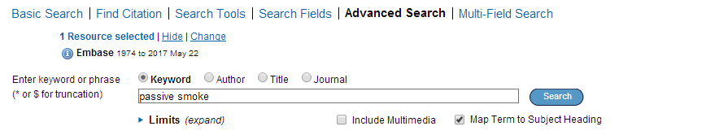

From here you can select Explode, which expands results to include records about the broader topic and all related topics and Focus which retrieves only those results that pertain to the subject heading.

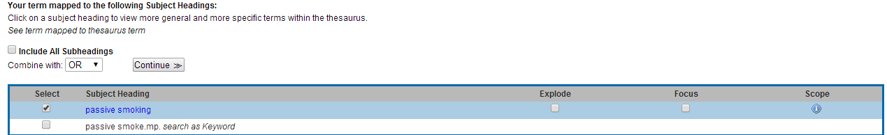
Exploded terms:
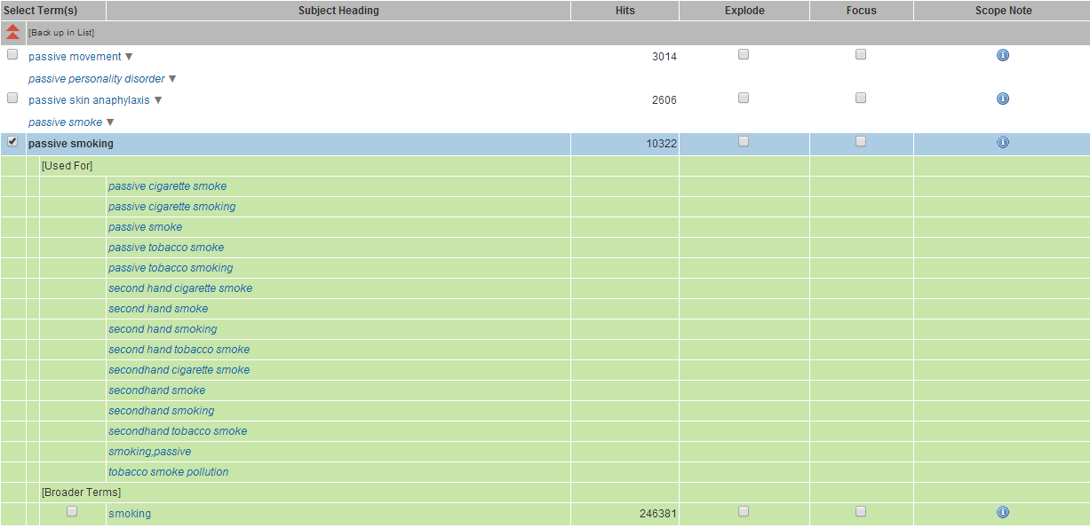

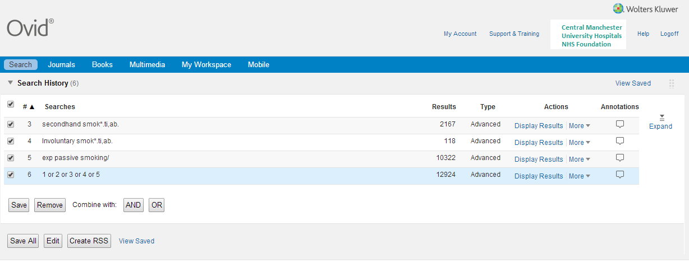
Now we want to combine these terms with the Boolean operative OR. So far our search on EMBASE looks like this:

We can now add our second search term, ‘lung cancer’. Remember, there are various synonyms for ‘cancer’, and you must use all of these in your keyword search. You can search for them like this: (lung* AND (cancer* OR neoplasm* OR carcinoma*)).ti,ab Notice that the search terms must be in parentheses.
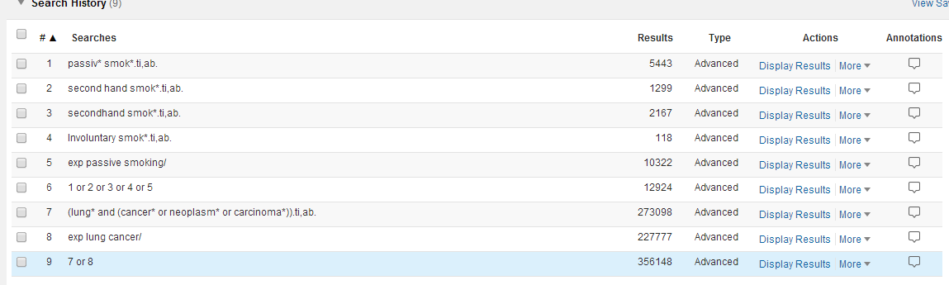
Now we can combine the two search components, in this instance lines 6 and 9:
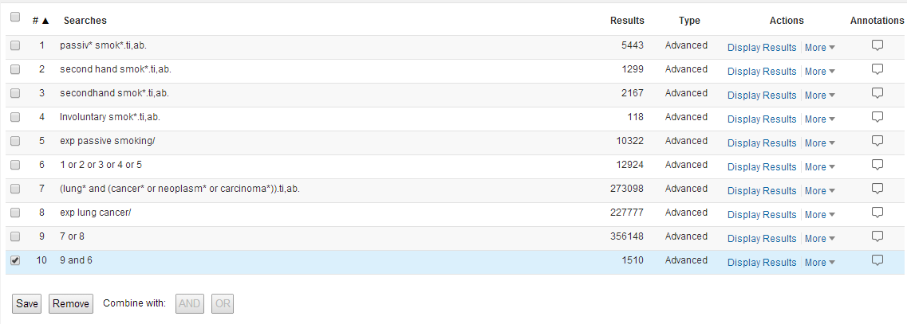

Applying Limits
To apply limits to your search, tick the line you wish to limit (in our case line 10) and then tick the ‘Limits’ box and choose the limits you want. To see the full list of available limits, select Additional Limits. Then click ‘Limit A Search’. Here we have limited to English, Male, Adult, Full text and the dates 2007 -2017.
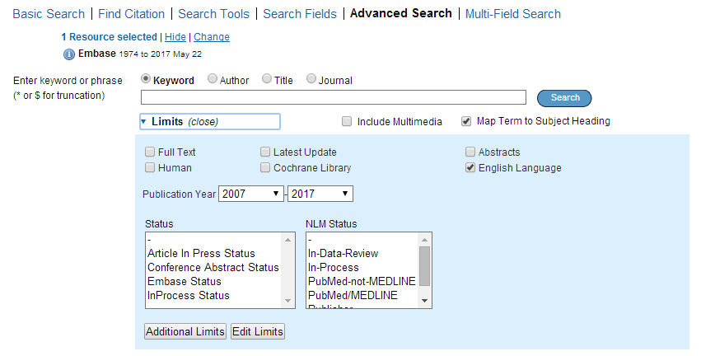

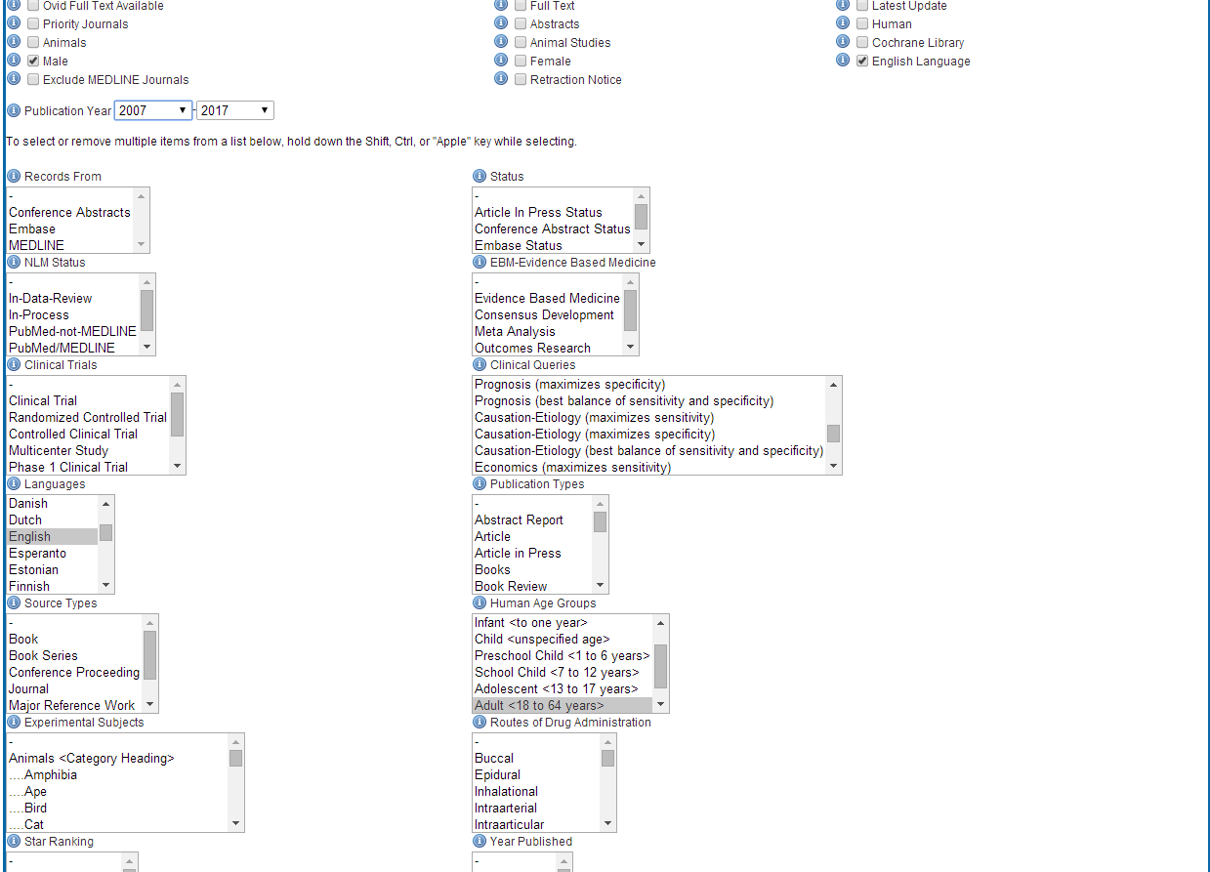

You can also filter for Clinical Query.

The Clinical Query Limit
Clinical queries are pre-tested search strategies (or filters) which are made up of search terms that identify the methodology of a study. They are used as an effective way to retrieve particular types of studies that answer questions relating to therapy, diagnosis, prognosis, aetiology/etiology etc.
Selecting the appropriate filter, will:
- increase the relevancy of your search
- introduce a level of consistency to your searching making it more systematic
- save you time in when conducting your search
- provide you with a particularly useful way of limiting a broad search
Clinical queries are available in Embase and CINHAL.
Filters may have: High sensitivity (broad) - giving most results
High specificity (narrow) - giving least results
Optimized – giving medium results

The Search Results
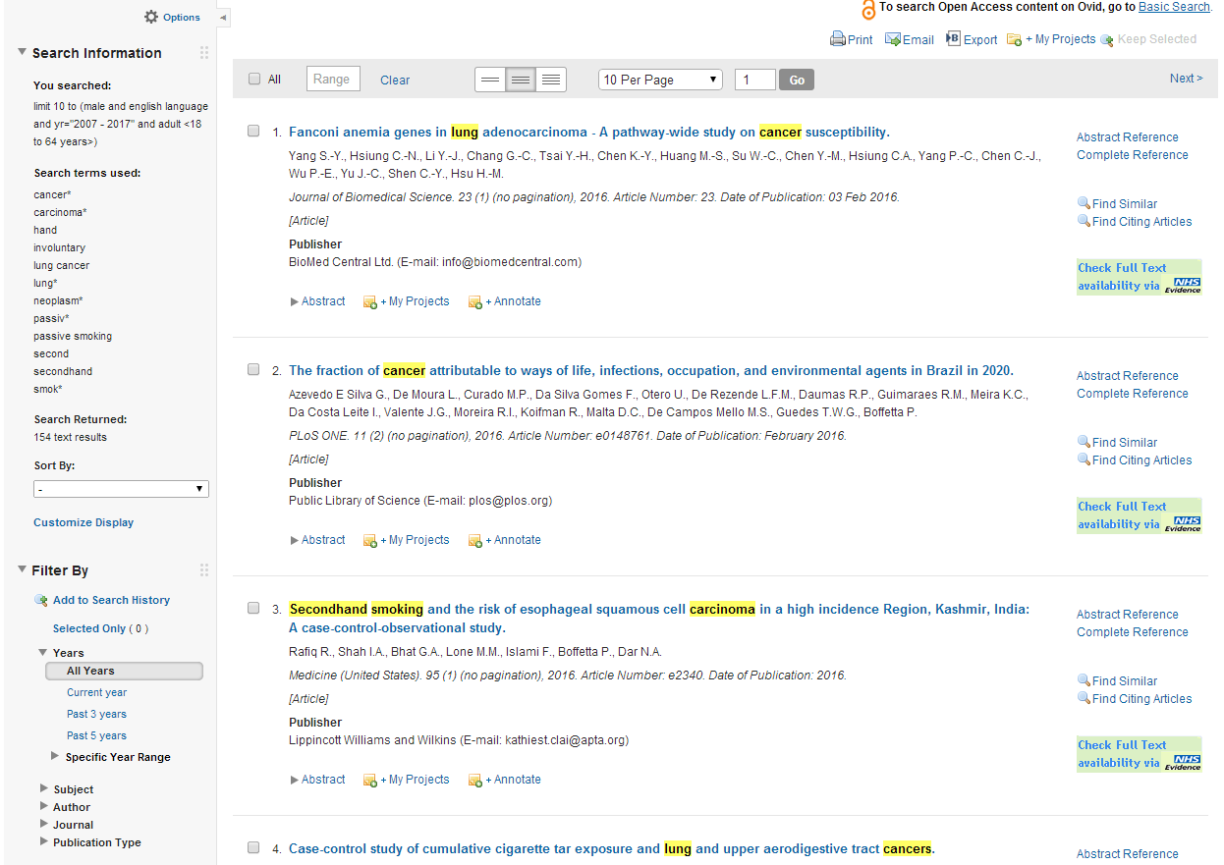
Below you can see the final results with limits.
To view the results click ‘Display results’. The results are displayed as follows:
Click on title link to display the full reference
Look out for links to full text on the right of the screen

If you require the full text for a journal article but so not see a link, you have the following options:

- First check the library catalogue to make sure it is not held at the library.
www.mft.nhs.uk/library > Library catalogue
- Check Browzine. https://browzine.com/libraries/2901
- Use our document supply service. www.mft.nhs.uk/library > Document supply

Exporting results
To export your results, tick the line corresponding to the results you want to export, or choose All. Click on Export and choose the format you’d like and how you’d like your results displayed and then click Export Citations.
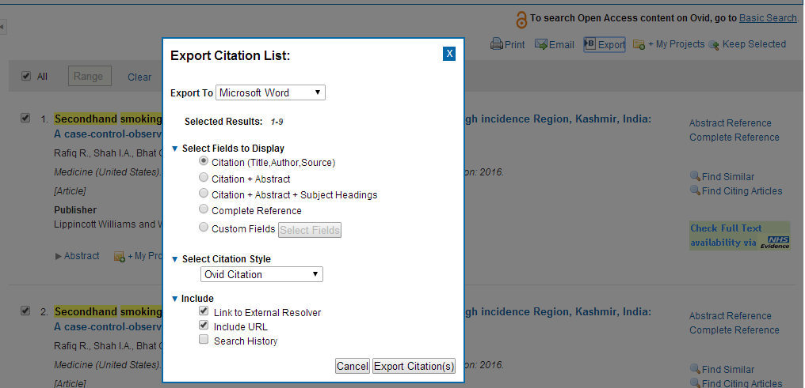

Changing Databases
Once you have finished your search you have the option of searching again using a different database. Click on Change and choose a different database from the menu.
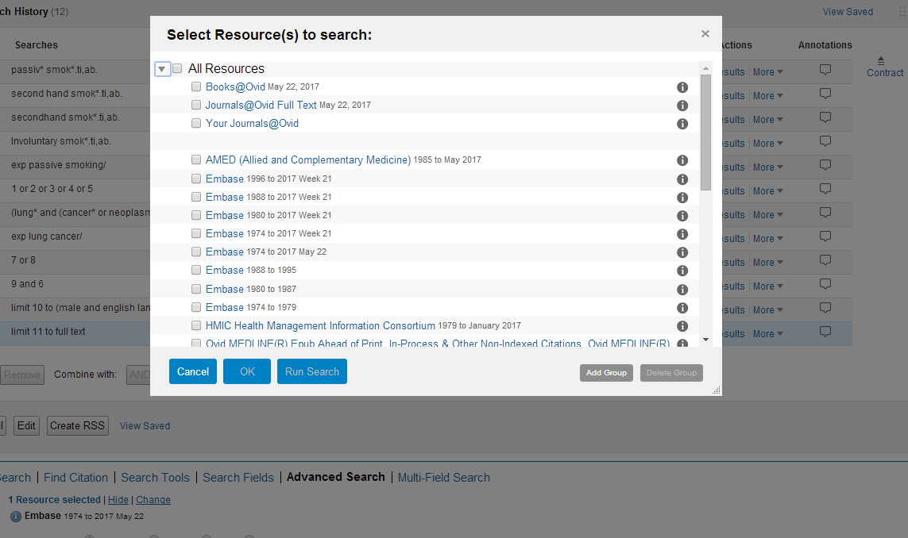

Saving your search
In order to save your searches, you will need to register with OVID:

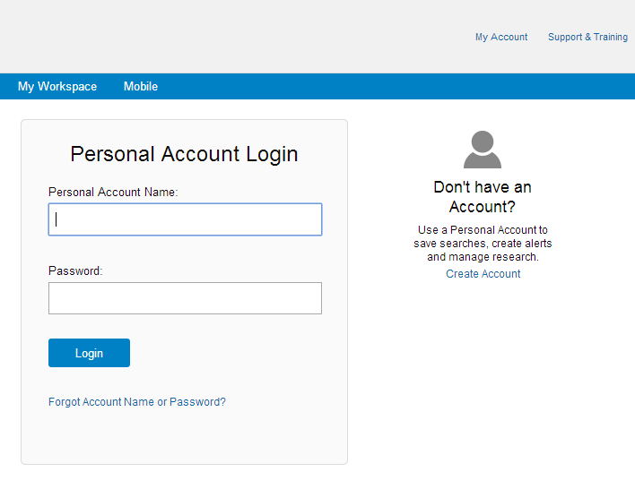

Once logged in you can save selected rows or the entire search.

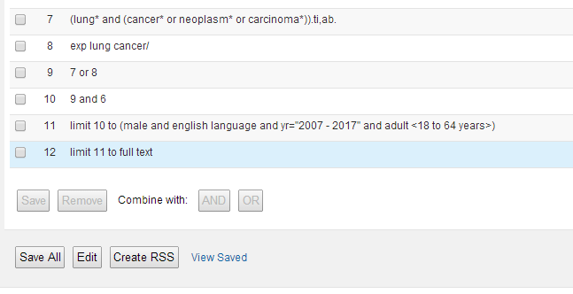

To view or open saved searches click on ‘View Saved’ in the top right corner. To re-run the search tick the box and select Run.
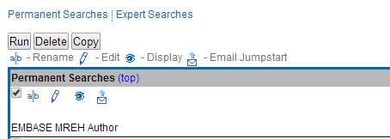

Common syntax:
Select all articles by clicking the select all results link
There is a common way of searching across all Healthcare using the same wildcards and operators. Here is a brief overview.
TRUNCATION | SYMBOL
A way to search for alternative endings of words. You need to think of the root of your word and apply the wildcard *.  Unlimited truncation e.g. manag* finds manage, manages, managing, managed, management etc.  Be careful however e.g. nurs* finds nurse, nurses, nursing, nurse-led but also nursery. | *
Limited truncation: number (n) specifies the maximum characters after wordstem e.g. Child*4 finds child, children Doesn’t find Childhood, childless | *n
The optional wild card character ? (question mark) can be used within or at the end of a search term to substitute for one or no characters. This wild card is useful for retrieving documents with British and American word variants. Example colo?r retrieves results that contain the words color or colour. You can use multiple wild cards in a single query word. | ?

BOOLEAN OPERATORS
Finds records containing BOTH terms.  e.g. heart and exercise | AND
Finds records containing either term  e.g. smoking or tobacco | OR
Use brackets to include more than one type of operator e.g. (diet or nutrition) and diabetes | ( )
Excludes terms – use with care  e.g. Alopecia not (cancer or chemotherapy) | NOT
Will default to AND | No command

PROXIMITY CONNECTORS
Finds records where the terms appear within n words of each other in either direction.  e.g. hyperactiv* adj7 child* finds e.g. ‘child/children who are diagnosed as being hyperactive....’  note: hyperactiv* will also pick up the term ‘hyperactivity’ which should further improve the results. | ADJn

PHRASES
Use adj between words or quotation marks to find a phrase.  e.g. “play therapy” finds play therapy only.  It will not find play-based therapy, play and music therapy | “……..”

HYPHENATED WORDS
There is no need to include hyphens (-) in search terms such as  hand washing or side effects, as the results will be the same.  Keep in mind that terms such as hand washing and well being may also be written as handwashing or wellbeing. | -

Refining a search

What to do if you don’t find what you are looking for? Searching for literature can occasionally lead to unsatisfactory results. There are generally two types of problems that may be encountered:
- Too many irrelevant articles in the search result
- Too few relevant articles generated by the search.
Ideally when carrying out a literature search the results should find all of the articles which are relevant to the question, while excluding any article which is not relevant.

Too Many Irrelevant Articles
If the search results contain a large number of irrelevant articles, try:
- Using the thesaurus
- Using the NOT command to exclude a concept which is not wanted. (Use only if results have a strong bias towards a topic that you do not want at all as you may remove some useful information.)
- Searching for phrases using “ ”. For example, if you search for Mental Health without quotation marks, the results generated include irrelevant hits where the words mental and health appear in any order, anywhere in the title or abstract.
- Think of more precise keywords that can be used/added to the search.
- Using the Limits, such as limit to geographical location, age group etc.
- Limiting the date of publication range.
- Searching by Title, or title and abstract, rather than all fields.
- Using the combine search option to fine tune your search.
- Select Focus instead of Select.

Not Enough Useful Articles
If the search results do not contain enough useful articles, try:
- Alternative spelling – Use the American and European spellings of a word. For example, gynaecology or gynecology
- Different synonyms – try using alternative words or phrases to describe your search topic/concept. For example, try ‘bandage’ as an alternative to ‘dressing’ as a search term.
- Searching an alternative database. i.e. switch from Medline to EMBASE Widening your search – your search may be restricted by too many different concepts. Try removing one of the search terms or limits.
- Using the OR command, e.g. wound care OR ‘wound management’
- Truncation – Use the * command to give suffix variations. For example, bandag* will find bandage, bandages, and bandaging
- Searching ‘in any field’ or ‘in title and abstract’ rather than just in title.

Note: If you are searching for results in a new area of research there may be few published articles.



Olivia Schaff - Clinical Librarian
Manchester University NHS Foundation Trust
Education South
Oxford Road, Manchester M13 9WL
Tel: 0161 276 11480
Trust Library Services
Here for you
Follow us on @mftlibraries
Follow us on @mftlibraries

