**PudMed user guide**

PubMed is a freely available interface that contains the Medline database, as well as additional content including “ahead of print” and in-process citations not yet indexed on Medline. OpenAthens login details are required to view the full texts of the articles.

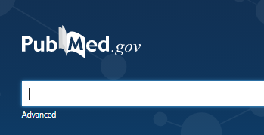

The Advanced search feature allows you to build your search, resulting in precise and comprehensive results.

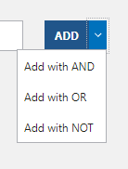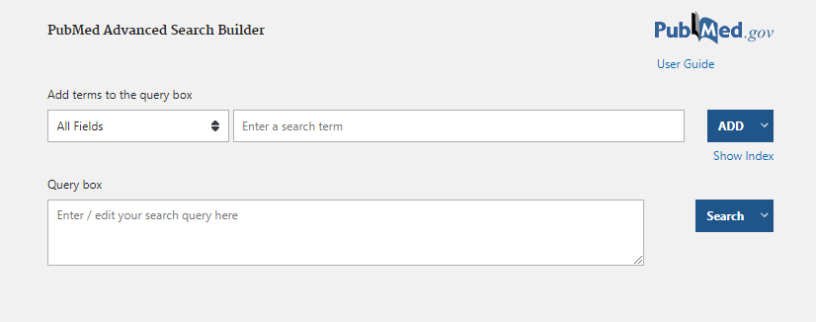

1. Enter search term.

2. Select a field from the drop-down menu to specify where the database looks for the search term in the record (e.g., Author, Title/Abstract).

3. Click on the downward arrow next to **ADD** to select a Boolean operator. This gives you the option to combine or exclude words before executing your search.

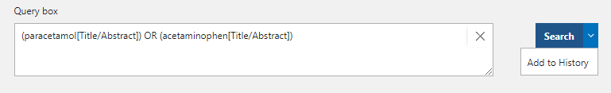

4. Your search term will appear in the **Query box**. You may wish to add other search terms or synonyms by repeating the above process. Alternatively, click **Search** to run the search.

5. You can add your search term straight to the **History and Search Details** section by clicking on the downward arrow next to **Search** and selecting **Add to History**. This is useful if you don’t want to examine the results for each line of your search.



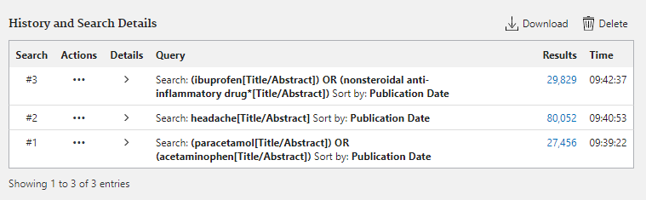

7. Click **MeSH** to search for subject headings.

6. Your search will appear in **History and Search Details**. The above process can be repeated to add additional keywords to your search.

8. Enter term and click **Search.**

9. Select relevant term from the list. Click to view additional information.

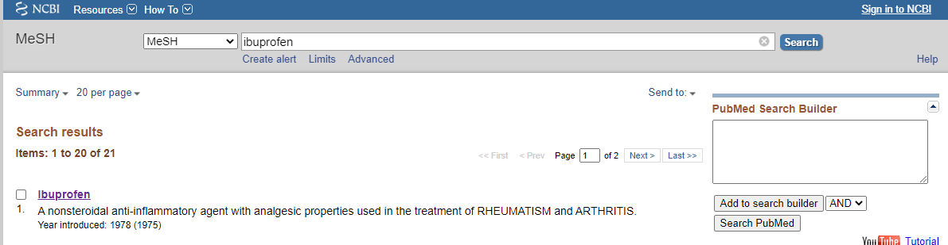



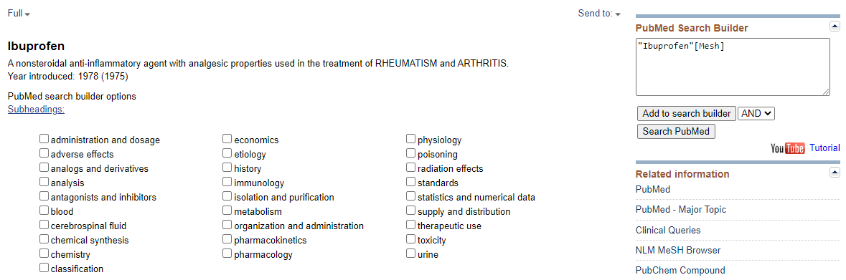

9. Select desired subheadings.

10. Click **Add to search builder**, followed by **Search PubMed**. This will run the search. 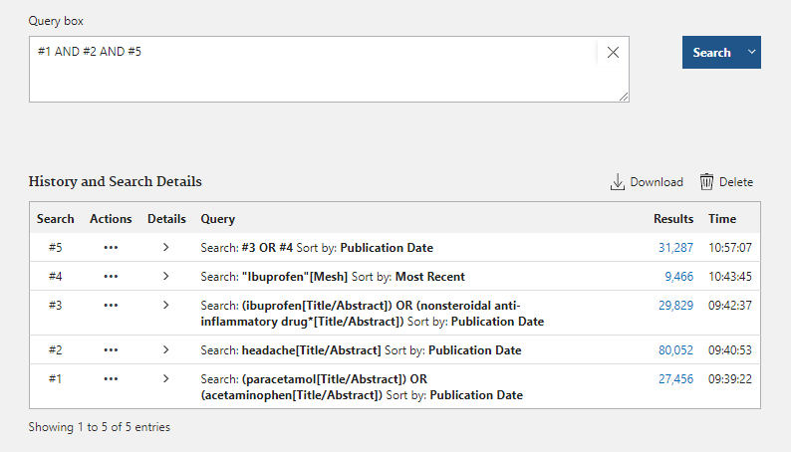





11. Click **Advanced** to view your search history.

12. To combine your searches, type the corresponding search line numbers into the **Query box** and combine using Boolean operators (**AND, OR, NOT**). Click **Search**.



13. Use the filters on the left-hand side to narrow down your results, including by publication date and article type.



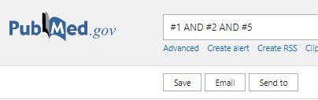

If you need any additional support or would like to book a one-to-one training session, please don’t hesitate to contact the library.

14. To export your results to a citation manager such as Endnote or Refworks, click **Send to** followed by **citation manager**. To export them to a excel spreadsheet, click **Save** and change the format to **CSV**.