Team Members
Points

A Christmas Carol
The following are all questions about Charles Dicken’s A Christmas Carol including some of the numerous adaptations of the story. 1 point for each correct answer.
1 | What is Scrooge’s first name?
 | Answer:
2 | Who was the first ghost to appear to Scrooge?
 | Answer:
3 | Who was Scrooge’s first employer?
 | Answer:
4 | What is the first name of Scrooge’s nephew?
 | Answer:
5 | What were the names of the 2 children the Ghost of Christmas Present warned Scrooge about?
 | Answer:
6 | In the 1951 film Scrooge who played the main character?
 | Answer:
7 | In the 1988 film Scrooged who played the main character?
 | Answer:
8 | Which Muppet played Bob Cratchit in the film The Muppet Christmas Carol
 | Answer:
9 | In 2000 which “special army soldier” portrayed Scrooge as a loan shark in ITV’s modern adaptation of A Christmas Carol?
 | Answer:
10 | Who plays the ghost of Christmas Present in the 2022 film Spirited?
 | Answer:

Christmas past
The acts below have all had a number 1 single at Christmas. 1 point for each of the following:
- Name of the act
- Name of the song
- Year they were number 1

1 | 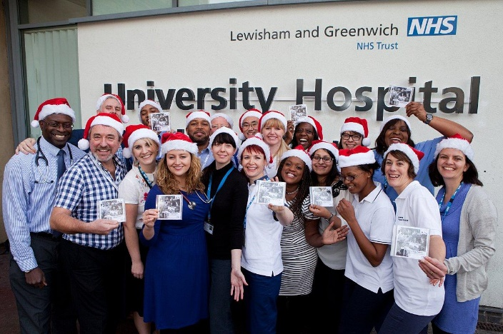  Answer:
2 | 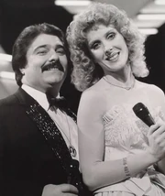  Answer:
3 | Answer:
4 | 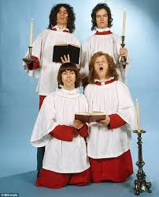  Answer:
5 | 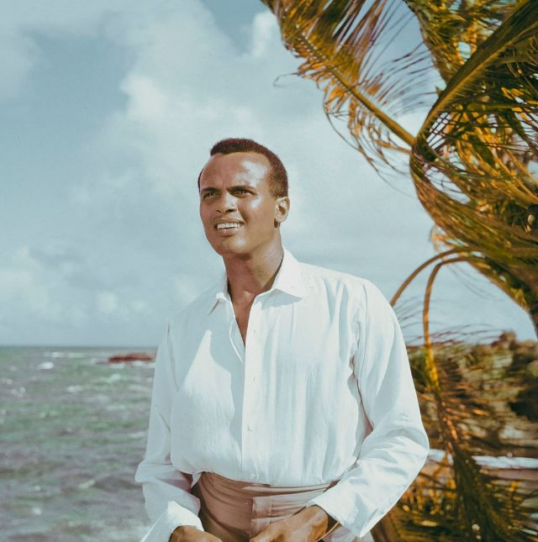  Answer:
6 | 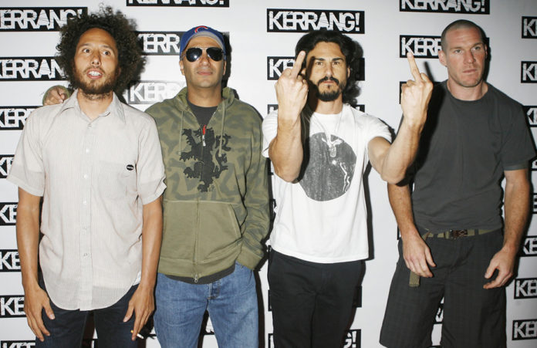  Answer:
7 | Answer:
8 | Answer:
9 | 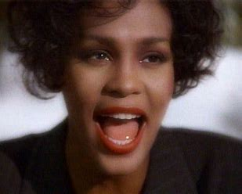  Answer:
10 | 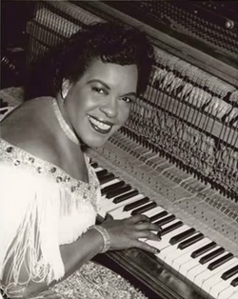  Answer:

Christmas Presents
The following are toys which have been best sellers at Christmas but with some of their letters missing. Fill in the blanks. 1 point for each correct answer. The year the toy was number 1 is in brackets.
1 | _M_ / _ik_ (1977)
 | Answer:
2 | _u_i_ / C_ _ _ (1981)
 | Answer:
3 | _ _un_e_b_r_s / _r_c_ _ / _s_a_d (1993)
 | Answer:
4 | _i_h / _ _h_o_/ M_s_c_l / _a_ce / _a_ (2009)
 | Answer:
5 | _ _rb_ / B_ _ _ (2013)
 | Answer:

Yet to come
The following are all scheduled to take place in 2023. One point for each correct answer.
1 | In January which country will adopt the euro as their currency and become the 20th member state of the eurozone.?
 | Answer:
2 | On January 4th it will be the 10-year anniversary of Mark Cahill from West Yorkshire becoming the first person in the UK to receive what?
 | Answer:
3 | Chinese New Year will fall on Sunday, January 22nd starting a year of the what?
 | Answer:
4 | On March 26th it will be the 50th anniversary of what first for the stock exchange?
 | Answer:
5 | What will take place on May 6th at Westminster Abbey?
 | Answer:
6 | What fabulous event will take place in Liverpool on May 13th?
 | Answer:
7 | What will take place between July 20th – August 20th in Australia and New Zealand.
 | Answer:
8 | What highly illogical event takes place on September 8th?
 | Answer:
9 | What fiery event will take place on October 14th?
 | Answer:
10 | 31st December will the 100th anniversary of what being broadcast on radio for the first time by the BBC?
 | Answer:

